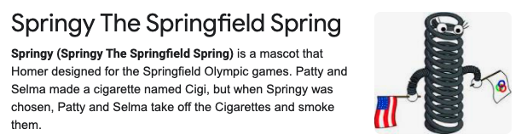**Springy the Springfield Springs**

**Project 2 – Claira, KJ, Britt, and Lora**

**Project 2 Schedule:**

Saturday (7/17): Heroku deployments (1 hour), review pitch with me in your groups, group work  
Tuesday (7/20): Group work  
Thursday (7/22): Group work  
Saturday (7/24): R-apalooza  
Tuesday (7/27): Group work  
Thursday (7/29): Final group work (1 hour), presentations

1. Brief articulation of your chosen topic
   1. Olympic games analysis –
      1. Dashboard to visualize total medal count, gdp, and population over time per county. Built in automated racing chart by country over time that auto runs on page load. User enabled filtering to dive deeper into data on selected option(s). Map visualizations for where Olympics have been held with possible tooltip to show information for that locale/year, maybe top 3 country medal count or something along those lines.
2. A link to your data set(s) and a screenshot of the metadata if it exists
   1. <https://worldpopulationreview.com/country-rankings/olympic-medals-by-country>
   2. <https://www.kaggle.com/the-guardian/olympic-games>
3. 3 or 4 screenshots of relevant or inspiring visualizations that frame your creative fodder

We let the Olympics steer our creative fodder.

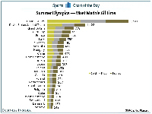 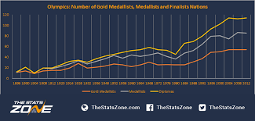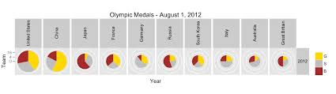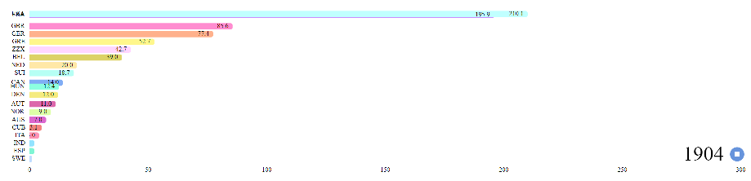

1. A sketch of the final design

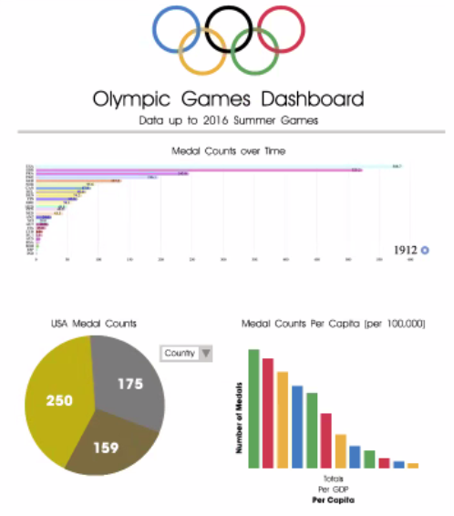

1. A link to the primary GitHub repo you’ll be housing your work in.

<https://github.com/julia-claira/project3_group_springy_olympics>

**Tasks:**

Brit – bubble chart, year/medal by country over time, dataset, summary write

KJ – sqlite database, joining, merging, geo map

Claira – html, javascript, racing chart overtime to show country medal count in racing form, dataset

Lora – line chart to show over time: medal count/GDP/population with pie chart for medal count

**Presentation**: TBD